How to measure hight voltage on your survey meter

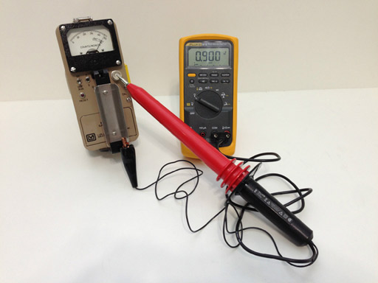
The pictures show HV measurement of a Ludlum Model 3 Survey Meter measured at 900V, the perfect setting for most Ludlum and other manufactures compatible GM Tubes and many Scintillation Detectors. Don’t burn out that expensive PMT (photomultiplier) or Geiger tube; be sure of your voltage with one of these high quality Fluke probes.

The Fluke 80K-40 is a ONE GigaOhm resistance probe that when used in combination with your Multimeter allows the measurement of High Voltages at a 1000 to 1 ratio with excellent accuracy. This is the perfect item to measure the HV on your Survey Meter or other low energy High Voltage devices. Don’t burn out that expensive GM or Scintillator probe by guessing at the voltages. And don’t try to use just any multimeter alone without one of these probes, as your HV reading will NOT be accurate, and most likely will read well under the actual voltage if it reads at all. And don't try reading your Survey Meter with a Fluke 80K-6, as that probe does not have enough resistance to accuratly measure low energy devices like battery powered Survey Meters.
Of course these HV probes are useful for TV, Ham Radio, Oscilloscopes, Education Instructors and Students, as well as many other uses. It’s long reach can easily get into tight and otherwise hazardous places.
These HV Probes work well with most multimeters that have a 10 MegOhm input impedance (most decent meters have this), a VDC setting (volts DC), and standard spaced banana input jacks.

Manufacture Information:

The 80K-40 is a high voltage probe designed to extend the voltage measuring capability of an AC/DC voltmeter to 40,000 volts peak AC or DC Overvoltage Category I. This means the probe can only be used to make measurements on energy limited circuits within equipment. Examples include high voltage within televisions or photo copy machines. DO NOT use this probe to measure high voltages on power distribution systems. The probe provides high accuracy when used with a voltmeter having 10 MegOhm input impedance (the probe itself has a high quality 1 GigaOhm resistor network).

