SERIES 10 PORTABLE MULTICHANNEL ANALYZER CANBERRA (model 1004)

Operator’s manual

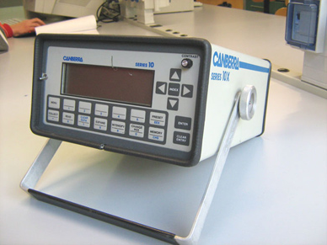

Front Panel

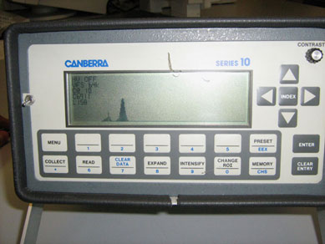

- Collect : causes the analyzer to start or stop data collection.
- Read : starts or stops data readout or readin.
- Clear data : clears data channels or time channels.
- Expand : expands the data display to show the 200 channels around the cursor.
- Intensify : changes the display to show regions of interest.
- Change roi : enters or delete rois.
- Memory : display any part of the memory.
- Preset : enters a preset value at which data collection will automatically stop.
- Menu : is covered in section 3 and 4.
- Enter : used to enter parameters into the memory.
- Clear entry : used to delete incorrect entries.
- Index : moves the cursor from one roi to another.

Rear Panel

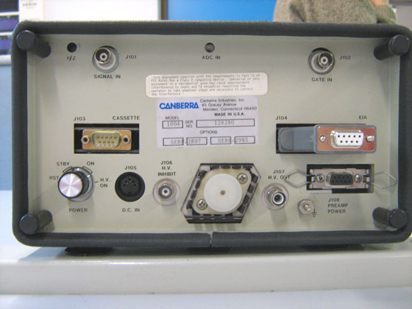

The rear panel carries the power switch and seven signal connectors.

POWER SWITCH The power switch has six positions: 1RST, 2-3 STBY, 4-5 ON, and 6 HV ON.
The STBY and ON positions are both doubled to provide some protection against accidentally moving the switch from ON to RST or from STBY to HV ON.

- Rst: Reset clears the data memory and initializes the default system parameters. The power switch must be in the rst position for at least 15 seconds for the current parameters.
- Stby: Standby shuts off power to all of the unit except the memory.
- On: On supplies power to all circuits.
- HV on: HV ON turns on the internal High Voltage Supply, which must first be enabled and set for correct voltage through the SETUP dialog.

Initial display

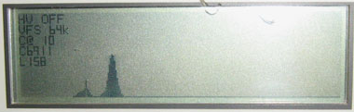

- HV : shows the high voltage output +10% or -10%. The reading will remain constant unless the measured output is beyond +2.5% or –2.5% of the setting.
- VFS: shows the display’s vertical full scale, in counts.
- C@ “n”: means the CURSOR is at channel number “n”. Channels are numbered relative to the displayed memory segment.
- C ”n”: means the COUNTS in the cursor’s channel are equal to “n”.
- Preset line: depending on the preset, shows:
The letter “L” – elapsed PHA Live time;
The letter “T” – elapsed PHA True time;
The letter “S” – elapsed MCS sweeps.

A computational preset will show the elapsed live time on this line.

- Status Line: displays error messages and shows the Series 10’s current status (MCS, READ). In PHA collect, it shows the percent dead time as a moving bar-graph. The line will be blank if the series 10 is idle.
- The baseline is the bottom of the spectral data display.
- The rest of the display is for spectral data.

When the series 10 is in the menu mode, the data display will be moved up so the bottom two lines can be used for menu prompts and the soft key labels.

The lower line is the Soft Key line, displaying all soft key labels. It also displays an error message if you issue an incorrect command.

The second line from the bottom is the Command Line; it shows dialog prompts and current parameters.

Using the menu

With the Series 10’s power switch turned ON, you can start to use the menu.

Press the front panel hard key marked :
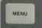

To see a line of soft-key labels on the bottom line of the display:

SETUP ECAL COMPUT ANALIZE ETC

This is the first line of the menu “tree”. It is shown on the display’s Soft key Line, the bottom line of the display. When any key is pressed the line of soft keys labels will change to show the next “branch” of the tree.

You can leave the dialog at any time by pressing the MENU key. Any selections ENTERed up to that point will have been recorded in the parameters memory.

Default parameters

To see the default parameters, press

MENU SETUP STATUS

The display will change to show a listing all of the current system parameter display.

High voltage power supply

To select the high voltage follow the istructions:

- Turn the power switch on the position H.V. on;
- Menu;
- Setup (number 1);
- Etc (number 5);
- Hpvs (number1);
- Set (number 4);
- Insert the number of the high voltage;
- Enter to confirm;
- On (number 1).
Live time
+
To select the live follow this istructions:

- Switch on the canberra;
- Menu;
- Setup (number 1);
- Status (number 4);
- Preset bottom;
- Change (number 1);
- Live time (number 1);
- Enter the number;
- Enter button.

Amplification gain

To select the amplification gain follow the istructions:
- Menu;
- Setup (number 1);
- AMP (number 1);
- Gain (number 5);
- Clear entry button;
- Insert the number;
- Enter.

Clear data
To clear the data press:
- Clear data (number 7);
- Data (number 1);
- Enter.
Misuration

- Collect button;
- Start (number 1);
- Enter;
- To Stop: press collect button and stop.

